Translating AncientGreek Documentation
Dear translator,
Since you are reading this, you are considering translating AncientGreek Documentation. This document is meant to help you start.
The translation can be done either off-line (using a ZIP file) or on-line (using Transifex).
Since the target of your translation will be HTML files, a basic understanding of HTML is required. Please refer to section “About HTML”.

Using Transifex
In order to use Transifex, you have to have an account, so please get to https://www.transifex.com and create one. Then contact me so that i can grant you access to the files for your language.
You can get to the project’s files at https://www.transifex.com/sng/ancientgreek
Working with Transifex is out of the scope of this document, but the process is more or less self explanatory and help is available online.
One thing I should mention is that you should Review any messages you have translated within a file. Reviewing is the process of marking a translation for insertion into the Transifex Translation Memor, so that other files may benefit already translated messages.
Reviewing messages is very simple, as you can as in the following image:
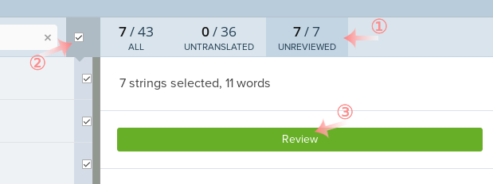
While you are on the translation page of a file, you get to see the number of messages, plus untranslated messages and unreviewed messages.
- Click on UNREVIEWED. All unreviewed messages will be loaded on the left hand side of the page.
- Clink on the check box to select all messages, or select individual messages.
- Click Review.
So, if this is your preferable way of working you should just go right ahead to Inspecting the result.

Using a ZIP file for off-line translation
You can get the ZIP file at http://members.hellug.gr/sng/ancientgreekoxt/files/AncientGreek-Documentation-docs.zip
The stracture of the ZIP file is:
AncientGreek-Documentation (top level directory)
docs
pot (POT files)
el (el PO files)
it (it PO files)
… (other languages PO files)
If you are starting a new language, just create a directory under docs, and copy all POT files there. Then rename them and change the extension of the filenames from pot to po.
You can have more info about translating off-line at http://members.hellug.gr/sng/ancientgreekoxt/l18m.html
Each time some updated PO files are sent to me, I will update the ZIP file and upload it for everyone to use.

Syncing off-line – on-line translations
I will try my best to keep the off-line (ZIP file) and on-line (Transifex) translations in sync. Please always consult the files’ time-stamps in order to get the latest files.

Inspecting the result
Unfortunately, there is no easy way to see the actual result of the translation; whenever new messages are added, I will update a ZIP file (you can get it here http://members.hellug.gr/sng/ancientgreekoxt/files/AncientGreek-Documentation-site.zip). Download this ZIP file and browse under the site directory to see the translated web pages.
This ZIP file stracture is:
AncientGreek-Documentation (top level directory)
site (documentation in HTML)
el (documentation in HTML for el)
it (documentation in HTML for it)
… (other languages HTML files)

Downloading the images
The previous ZIP file does not contain the images folder, just because it's very large (around 10MB or so) compared to the actual HTML pages, and it does not get updated as frequently.
So, if you want to see the images on the HTML pages, you should download the following ZIP file: http://members.hellug.gr/sng/ancientgreekoxt/files/AncientGreek-Documentation-images.zip
How will I know when to download this file again? you may ask. Well, when you see an image is missing on a translated page, then you will know it's time to update your local copy of the images.
This ZIP file stracture is:
AncientGreek-Documentation (top level directory)
images

Documentation translation guide

About the files
The files can be separated in three groups
- common.pot /common.po
This if the first file you should translate. The messages found in it are common to most of the web pages (hence the name).
- Web pages
These are the documentation web pages as seen when the Help button is clicked from any AncientGreek dialog.
- Topic web pages
These are special documentation web pages used to present topic specifichelp. They are actually part of the original web pages.
You should translate these files when all the other web pages are done; you will find they have already been filled in a larger percentage with messages that come from their original’s web pages translation.
In Transifex, the files are marked as ”Uncategorized”; files under any other Category do not belong to the documentation.
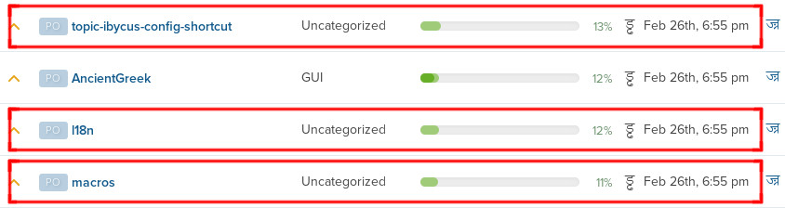

About HTML
When translating HTML code, it is important to understand what to translate and what to ignore.
The thing to understand is that anything that’s within a “<" and a ">” is not to be translated. For example:
<p class="any">This is a test</p>
In this message "<p class="any">" and "</p>" are HTML tags and must not be translated. The text "This is a test" is the actual string that should be translated.
There is an exception though: you should translate anything that’s inside a title=" and a ". For example:
<img src="any.png” title="any image" />
This is an image tag. As you can see, you should translate only the string "any image"; everything else is left as is.
The title parameter can also be found in more complex messages, like
<a href="http://any.org" title="Go to my home page">Go here</a>
Here, the strings to translate are "Go to my home page" and "Go here"; everything else is left as is.

HTML entities
HTML represents some characters with spacial code, starting with a "&" and ending with a ";". Examples are: &nbsp; , &bull; , &amp; , etc.
Example message:
<p>&bull; First item</p>
This will be displayed in the browser as
· First item
So the string to translate is: "First item"; everything else is left as is.
It is obvious that these special codes must not be translated.

AncientGreek specific codes
There are cases when it’s known that a message will be frequently changed, because of a small change within them, while the main part of the message will remain unchanged. In these cases, the frequently changing part has been replaced by a “code”, a string enclosed in “|”, and marked appropriately.
For example consider the message:
Version: 1.4-beta3
This message will be changed every time a new version is released, and will have to be translated over and again each time.
Changing the message to
Version: |DO NOT TRANSLATE – VERSION|
will make it immune to version changes; this means you will translate it once and it’s my job to place the correct version number in the translated web page.
For example this message would be translated to Greek, as:
Έκδοση: |DO NOT TRANSLATE – VERSION|
Other examples of such messages are:
|DO NOT TRANSLATE – DATE|
|DO NOT TRANSLATE – SCROLL|

Fixing translations that cannot be accepted on Transifex
Transifex performs several tests before permitting you to save a translated message. One of them is the existence of the right number of parenthesis, quotation, etc.
There are cases that you have to omit such elements as parenthesis, quotation, etc, but this seems impossible, since you won’t be able to save the message. Consider the following situation (message translation in Greek).
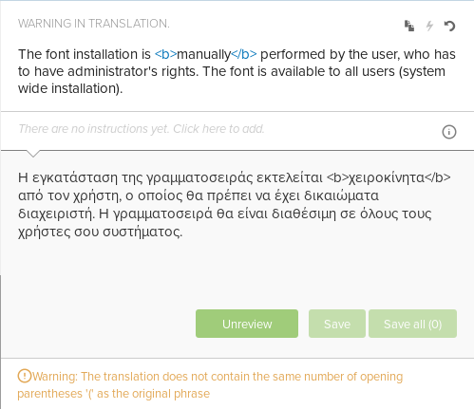
The translated message does not contain the parenthesis pair present in the original message.
What can you do? Well, you have to full Transifex, making it “think” that the parenthesis pair is actually present. The way to do that is using an “HTML comment”.
“HTML comments” consist of a “<!--” string followed by any text and ending with a “-->” sting. So “<!-- () -->” is a valid “HTML comment”. This is also the case with “<!-- “” -->” and “<!-- «» -->”.
An “HTML comment” will NOT be displayed when the HTML is rendered, so it may contain any kind of data.
In order to make Transifex accept the previous translation, a “<!-- () -->” comment is added to the actual message, as you can see bellow.
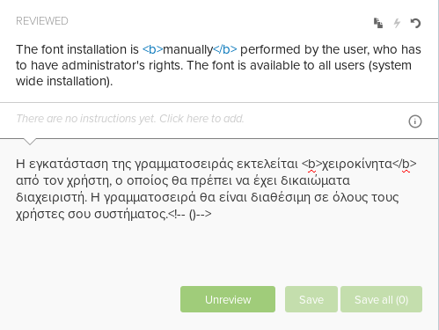
The message has already been saved and reviewed...

